2. 8-PUZZLE PROBLEM
Aim
To write a Python program to solve the 8-Puzzle problem.
Objective
To arrange the tiles in the correct order by moving the blank space.
Algorithm
Define the initial state and goal state.
Calculate the Manhattan Distance heuristic.
Insert the initial state into a priority queue.
Remove the state with the lowest cost.
If it is the goal state, stop.
Python code:
import heapq

goal = (1,2,3,4,5,6,7,8,0)

def heuristic(state):
distance = 0
for i in range(9):
if state[i] != 0:
goal_pos = goal.index(state[i])
distance += abs(i//3-goal_pos//3)+abs(i%3-goal_pos%3)
return distance

def neighbors(state):
moves = {
0:[1,3],1:[0,2,4],2:[1,5],
3:[0,4,6],4:[1,3,5,7],5:[2,4,8],
6:[3,7],7:[4,6,8],8:[5,7]
}

blank = state.index(0)

for move in moves[blank]:
new = list(state)
new[blank], new[move] = new[move], new[blank]
yield tuple(new)

start = (1,2,3,4,5,6,0,7,8)

pq = []
heapq.heappush(pq,(heuristic(start),0,start))

visited = set()

while pq:
f,g,state = heapq.heappop(pq)

if state == goal:
print("Goal Reached")
print(state)
break

if state in visited:
continue

visited.add(state)

for nxt in neighbors(state):
heapq.heappush(pq,(g+1+heuristic(nxt),g+1,nxt))

Flowchart: 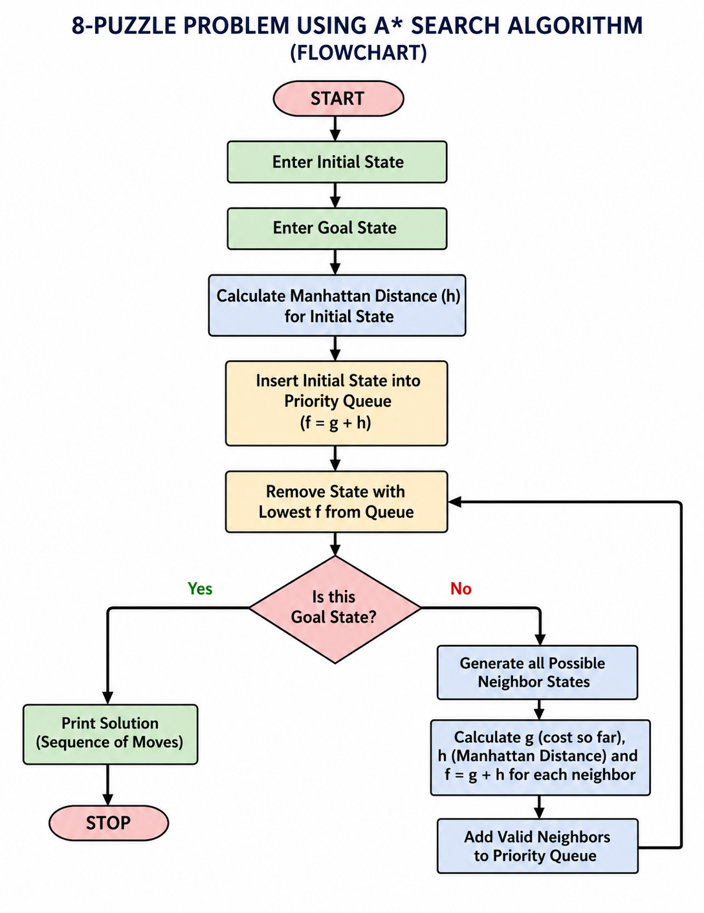

Output :
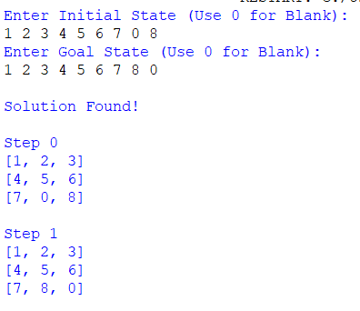
Result:
Thus, the Python program to solve the 8-Puzzle problem was executed successfully.

